# Implicit Association Test

Straight hairstyles vs. Other hairstyles

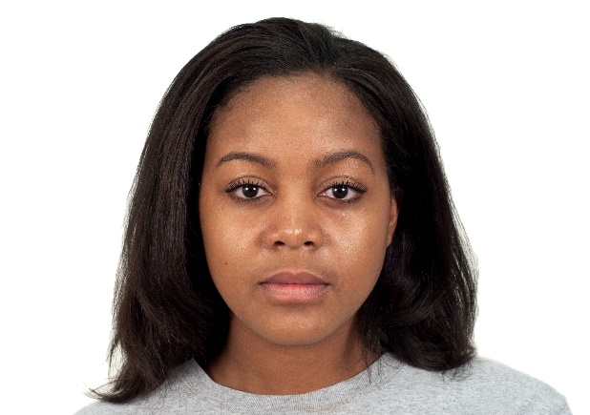 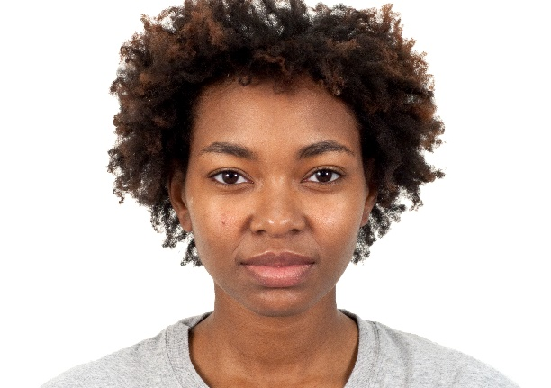

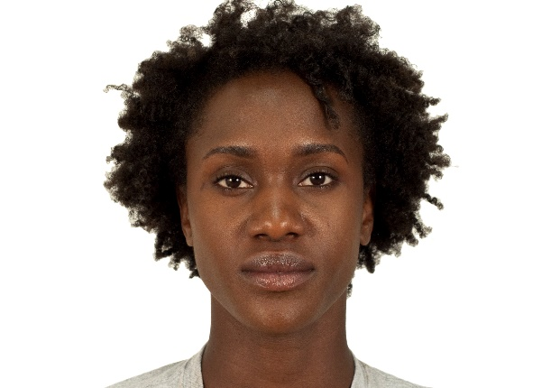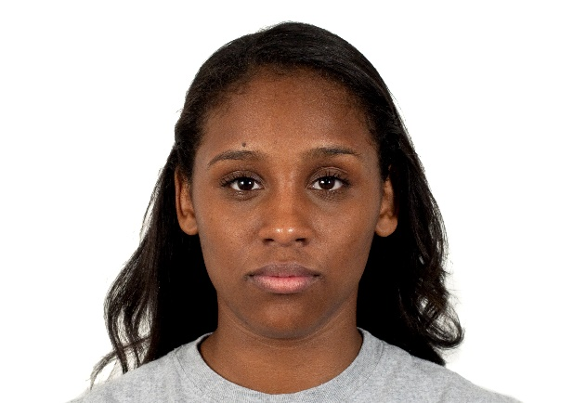

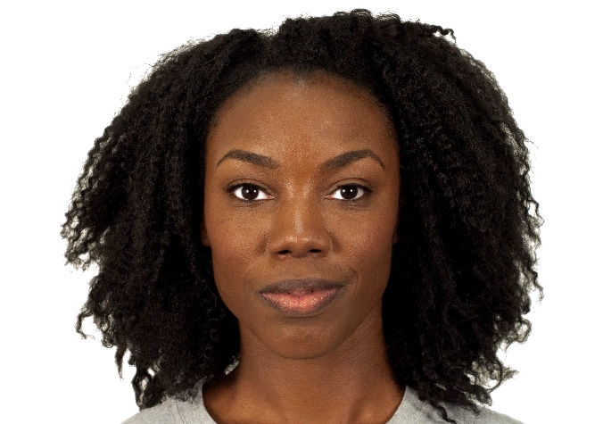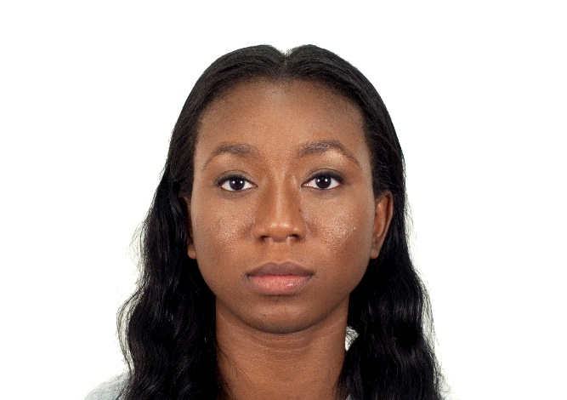

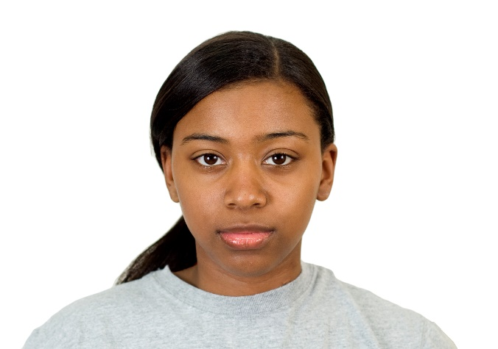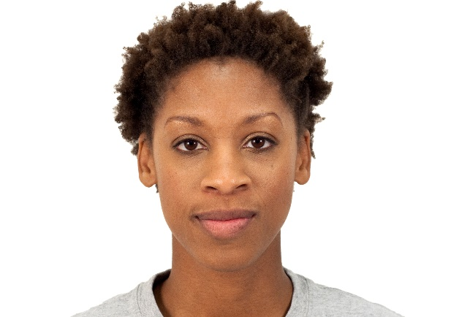

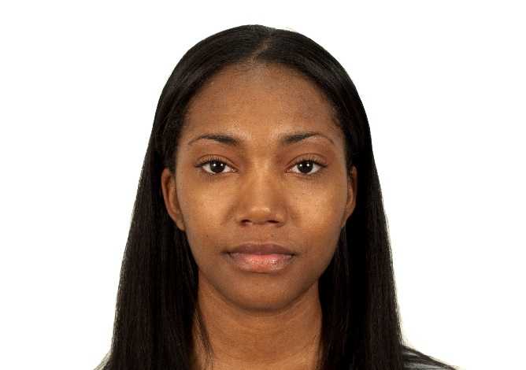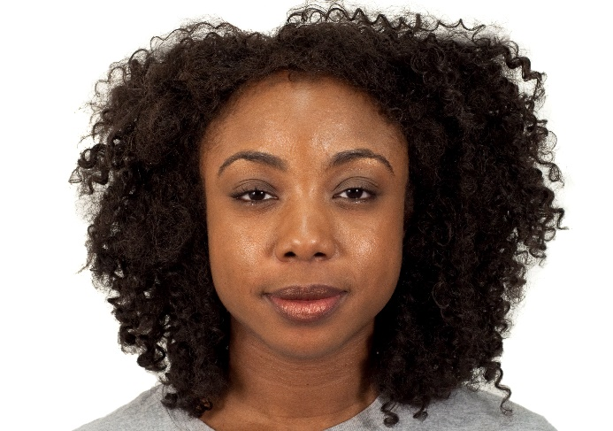

Professional/Unprofessional

* Professional, Appropriate, Acceptable, Suitable
* Unprofessional, Inappropriate, Unfit, Improper

Positive/Negative

* Professional, Capable, Competent, Appropriate
* Unprofessional, Incompetent, Incapable, Inappropriate

# Demographics

What is your age (in years)?

_______________

What is your current gender identity?

Female

Male

Trans female / Trans woman

Trans male / Trans man

Genderqueer / Gender nonconforming

A different identity ________________

How would you describe your race? (check all that apply)

American Indian or Alaska Native

Asian

Black / African American

Native Hawaiian or Pacific Islander

White

Other ________________

How would you describe your ethnicity?

Hispanic or Latino

Not Hispanic or Latino

How would you best describe your political affiliation?

Strongly liberal

Moderately liberal

Slightly liberal

Neutral

Slightly conservative

Moderately conservative

Strongly conservative

Current Hair style?

Straight

Curls

Short cut

Braids

Afro

Dreads

Other ___________